**45.ALV_hierachical Output**

Run the report in se38.Below is the Selection screen .Give a suitable CARRID and Execute.

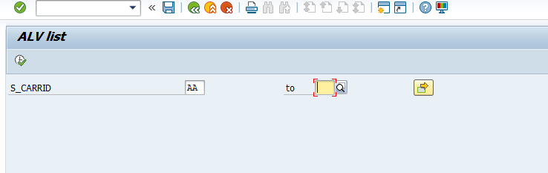

The expected output is as follows. Click on the expand collapse icon to see the hierarchy

